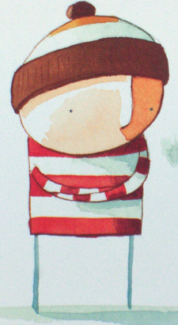

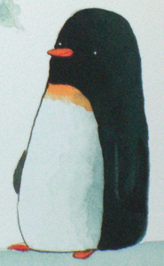

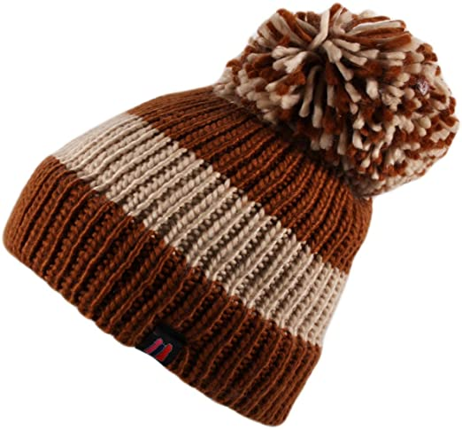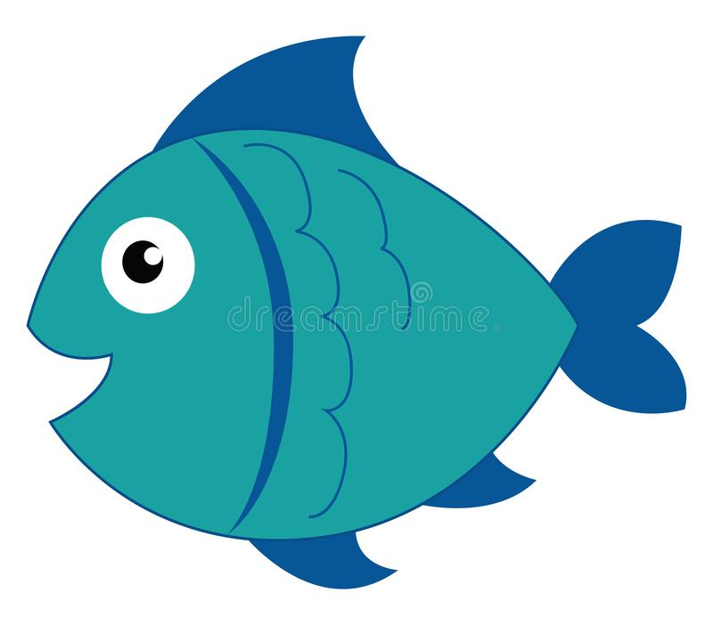

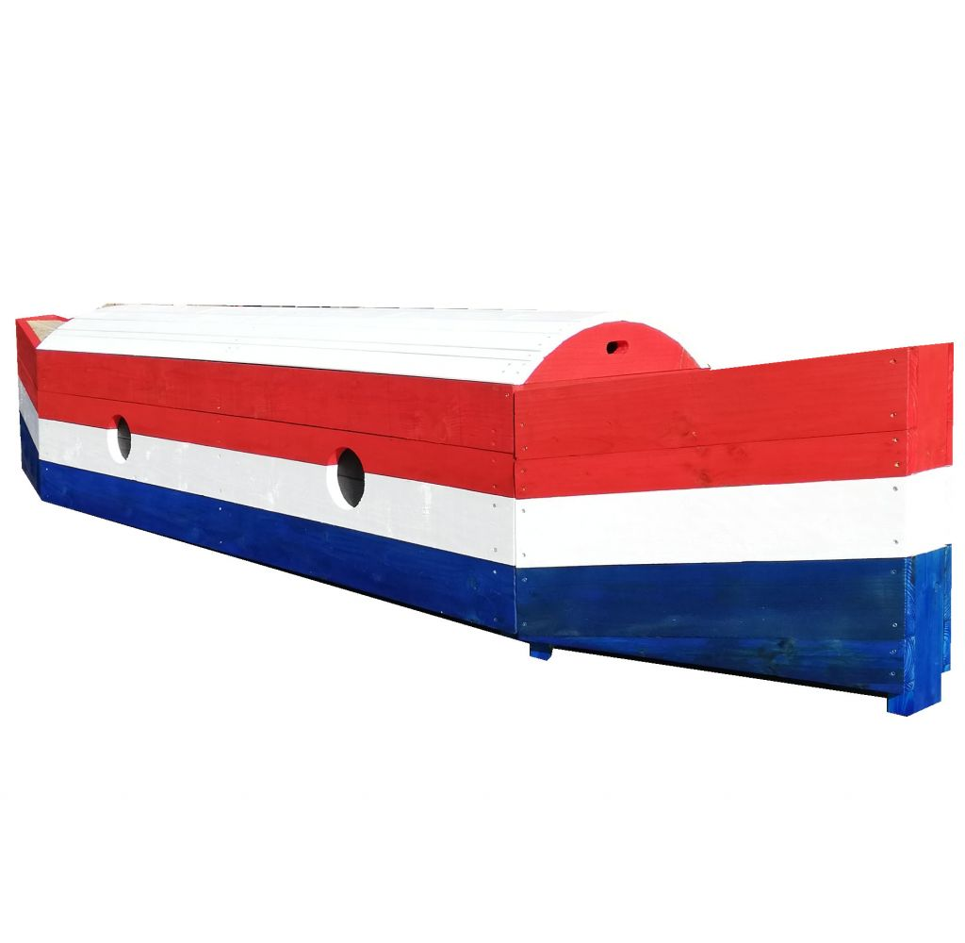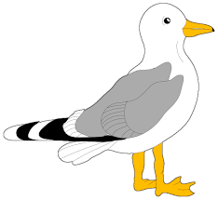 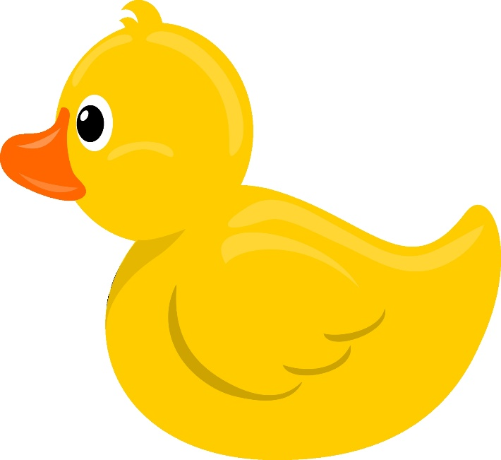

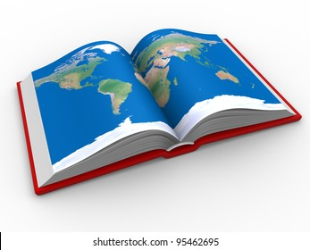

|  |
| --- |
| Put the map on the boy |
| Put the hat on the penguin |
| Put the duck next to the penguin |
| Put the boat under the boy |
| Put the fish on the penguin’s back |
| Put the gull next to the boy’s leg |
| Put the map on his leg |
| Put the hat on the boy’s chin |
| Put the duck on the penguin |
| Put the fish next to the boy |